7.55: The potential energy has decreased by The kinetic energy of the masses is then 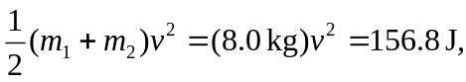 so the common speed is 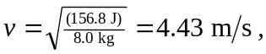 or 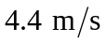 to two figures.

